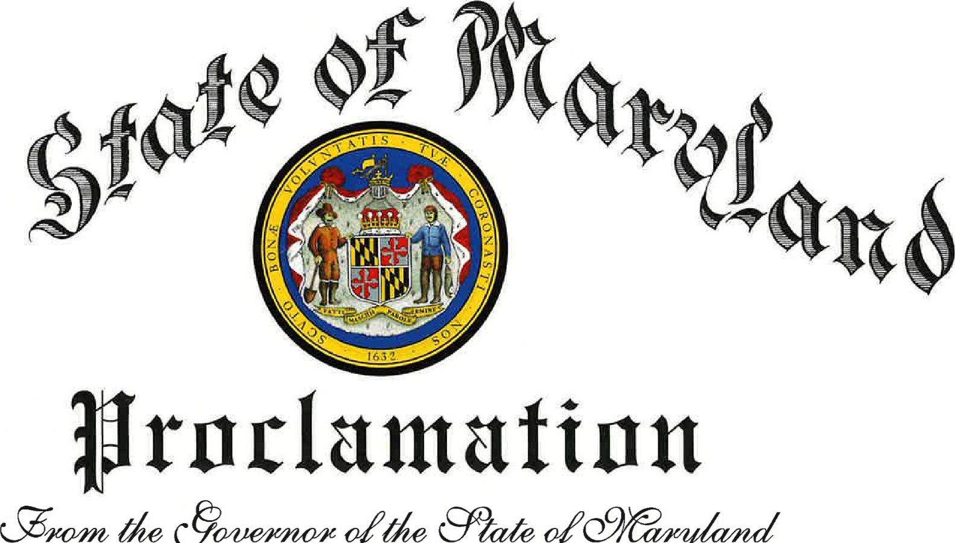
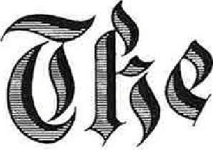
MARYLAND CLIMATE EDUCATION MONTH APRIL 2026

WHEREAS,  WHEREAS,  WHEREAS,  WHEREAS,  WHEREAS,  WHEREAS,  WHEREAS,  WHEREAS | The State of Maryland has a long history of environmental stewardship and a commitment to protecting the natural beauty and resources of our great state; and  Climate change poses a significant threat to our environment, economy, and public health; and  Maryland is uniquely positioned to lead in climate change education due to its diverse populations and ecosystems, vulnerable coastal areas, and the Chesapeake Bay, all of which are directly impacted by climate pollution; and  Education plays a vital role in raising awareness about climate change, its causes, consequences, and solutions; and  Maryland's primary and secondary schools, institutions of higher education, research organizations, and environmental and advocacy groups are at the forefront of climate change research and education and are the state's partners in this critical effort; and  Maryland benefits from strong partnerships with the University System of Maryland and advisory bodies such as the Maryland Commission on Climate Change, which provide the research, analysis, and policy guidance that inform the State's climate strategy and support climate education and engagement across Maryland's schools, campuses, and communities; and  Maryland is dedicated to fostering a culture of sustainability and environmental responsibility among its residents, businesses, and institutions; and  During this Maryland Climate Education Month, the State of Maryland encourages all to participate in educational activities and initiatives that promote climate change awareness and action toward Maryland's climate goals.

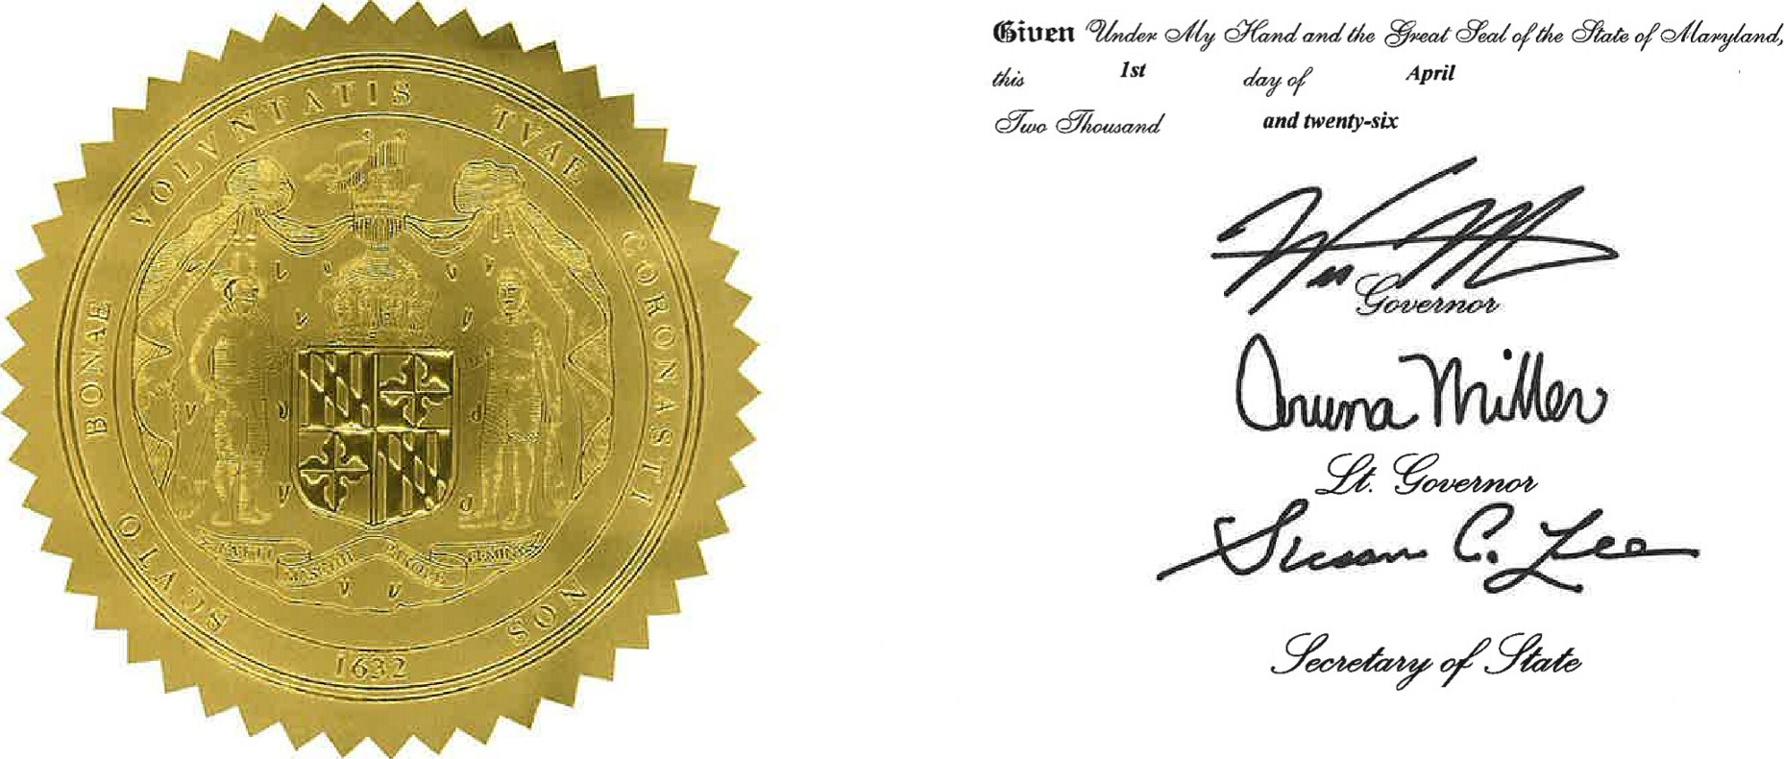
NOW, THEREFORE, 1, WES MOORE, GOVERNOR OF THE STATE OF MARYLAND, do hereby proclaim APRIL 2026 as MARYLAND CLIMATE EDUCATION MONTH in Maryland, and do commend this observation to all of our citizens.

